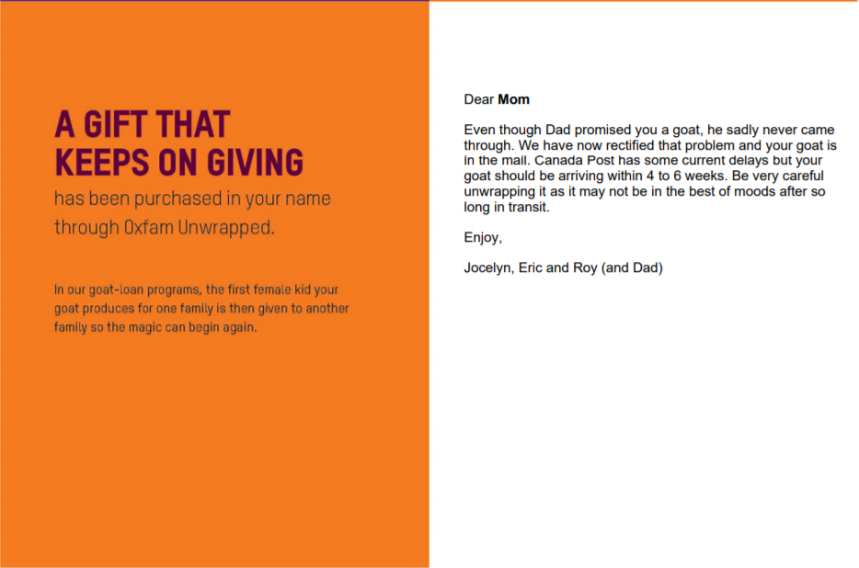

Dear Mom,

Even though Dad promised you a goat, he sadly never came through. We have now rectified that problem and your goat is in the mail. Canada Post has some current delays, but your goat should be arriving within 4 to 6 weeks. Be very careful unwrapping your goat as it may not be in the best of moods after so long in transit.

Enjoy your Goat!

Love,

Jocelyn, Roy and Eric

